# FISHEyE (FISHeries Economics Explorer) website

This document contains much of the information needed to understand and continue developing or maintaining the FISHEyE applications. This manual focuses on the Shiny portion of FISHEyE. The data analysis and files used to generate the data loaded into FISHEyE are minimally detailed in this manual. The document is divided into four sections, the basic information to get started, the data, shiny, and the server.

Table of Contents

FISHEyE (FISHeries Economics Explorer) website 1

Purpose 3

How to use this help document: 3

Basics 3

Shiny 3

State of the app 4

Getting help 4

First steps 4

GitLab 5

Once Git is established, take the following steps. 5

Updating files on GitLab 6

Hosting 7

Important Packages and Software 7

Framebuster and Appframe 8

Data 8

Data preparation folder Structure 9

Updating data 9

RunDataPrepCode.R 9

Compare Modules.R 10

A note on Oracle 10

FISHEyE App (fisheyeapp R project) 11

Shiny server 13

URLs 13

Server file layout 13

Development server 14

Production server 14

Deploying and Updating and on the Server 14

Deployment-update procedure 14

PuTTY or Command Prompt? 15

Transferring files 16

Logging in to the server 17

File system privileges 21

Viewing and editing a file on the server 21

Other linux commands 22

Transferring files codes (command prompt) 22

R packages 23

How to avoid specifying complete package paths in your app 24

Updating the index.html files 25

Updating data and adding years 26

Creating a new application 28

Data 28

Application 28

Trouble shooting 28

Checklist 31

Updated the data 31

Updated the Definitions or Instructions 31

Added a new year, added new functionality, revised how a value is calculated, etc. 31

Linux commands 31

File commands 31

Viewing and modifying files 31

File permissions 31

Search 32

In case of a government shutdown 32

R Shiny cheat sheets 32

Purpose:

FISHEyE is a web application to explore, analyze, and download economic data for the West Coast Groundfish Trawl Catch Share Program. It was designed to allow stakeholders and other interested users the ability to ask their own questions and evaluate the economic outcomes of the catch share program. FISHEyE utilizes EDC data. Results reported in EDC reports and FISHEyE should match. FISHEyE, in contrast to the EDC reports, can provide output for all possible ways to subset the data.

# How to use this help document:

This document provides a variety of tips and hints to help you understand and manage FISHEyE. Some information is specific to FISHEyE. Other bits may be relevant to other Shiny web applications. Information is not necessarily provided in the order you may need and may be in excess of what you need. Utilize the table of contents to jump around the document.

# Basics

To maintain FISHEyE you need to know about the data, the shiny code, and finally, the server. FISHEyE utilizes data generated from the fisheyedataprep RProject. You open this R project to update the data. Data is then saved into the Data folders in the fisheyeapp RProject. The fisheyeapp R project contains all the code and files for the fisheye web application. To make the web application available publically, you need to know how to load it onto the server and how to manage files on the server. For this, you need to use a file-copy application from your local computer, such as PuTTY and a command line application like pscp brought in in Command prompt

FISHEyE utilizes the Shiny package in RStudio. [Shiny](https://shiny.rstudio.com/) allows you to develop and maintain interactive web applications without knowledge of HTML, CSS, or JavaScript. Many Shiny tutorials are available online. HTML, CSS, and JavaScript are used to modify the web application beyond the basics layout provided by Shiny functions. Data in FISHEyE is generated in the fisheyedataprep R project folder. Data is pre-aggregated and compared against data in EDC Reports to ensure consistency. See the Data section for more information on the code and files relevant to data generation. The FISHEyE Application section outlines developing the web application on the desktop before deploying on the server (see Deploying).

## Shiny

This section is a list of useful resources for learning about shiny and gathering new ideas.

Shiny website has a tutorial, gallery of website examples, articles, references, information on deploying your app, and a help page: <https://shiny.rstudio.com/>

More examples. Some apps provide code. These are user-made apps in contrast to the apps provided on shiny.rstudio.com, which are often simpler RStudio examples to help: <http://www.showmeshiny.com/>

Financial examples with code: <https://systematicinvestor.wordpress.com/shiny/>

Shiny wikitech site: <https://wikitech.wikimedia.org/wiki/Building_a_Shiny_Dashboard>

Shiny wiki: <https://github.com/rstudio/shiny-server/wiki>

Website outlining R packages to improve Shiny. These are packages that improve and add on to basic shiny functions. Some incorporate Bootstrap components lick ShinyBS, others incorporate JavaScript components (shinyjs) and much more: <http://enhancedatascience.com/2017/07/10/the-packages-you-need-for-your-r-shiny-application/>

Tutorial from a shiny consultant (Dean Attali): <https://deanattali.com/blog/building-shiny-apps-tutorial/>

Another tutorial: <http://stcorp.nl/R_course/tutorial_shiny.html>

Another tutorial with lots of examples and advanced topics: [http://zevross.com/blog/2016/04/19/r-powered-web-applications-with-shiny-a-tutorial-and-cheat-sheet-with-40-example-apps/#details-on-the-package-versions-and-operating-system-used-to-create-this-post](http://zevross.com/blog/2016/04/19/r-powered-web-applications-with-shiny-a-tutorial-and-cheat-sheet-with-40-example-apps/%23details-on-the-package-versions-and-operating-system-used-to-create-this-post)

## State of the app

Currently FISHEyE consists of three applications or modules. These include the Net Revenue Explorer (<https://dataexplorer.northwestscience.fisheries.noaa.gov/fisheye/NetRevExplorer/>),

the Performance Metrics Application (<https://dataexplorer.northwestscience.fisheries.noaa.gov/fisheye/PerformanceMetrics/>), and the

Costs Explorer (<https://dataexplorer.northwestscience.fisheries.noaa.gov/fisheye/Costs/>). In addition, there is a landing page (<https://dataexplorer.northwestscience.fisheries.noaa.gov/fisheye/>). The landing page contains links to the three applications along with tabs that provide background information on what is FISHEyE, why it was developed, and what improvements are planned for FISHEyE. For information on how to modify the landing page see the Updating the index.html files section. Further applications can easily be developed. Potential ideas include the IO-Pac model and developing a predictive model (‘what if’ sort of analysis). Details and suggestions to help with developing an additional web application can be found in Creating a new application.

## Getting help

People

1. Howard Coleman ([homer.coleman@noaa.gov](mailto:homer.coleman@noaa.gov))

Contact Howard if you have questions on using the server or the framebuster and appframe packages.

1. Marcus Nedelmann ([Marcus.Neldelmann@noaa.gov](mailto:Marcus.Neldelmann@noaa.gov)

Contact Marcus for questions on the server and to request the server be refreshed or updated.

1. Erin Steiner ([erin.steiner@noaa.gov](mailto:erin.steiner@noaa.gov))

Contact Erin for questions on the data.

1. Shane Yamamoto ([shane.yamamoto@noaa.gov](mailto:shane.yamamoto@noaa.gov))

Contact Shane to get set-up on oracle.

1. Mike McCully ([mike.mccully@noaa.gov](mailto:mike.mccully@noaa.gov))

Contact Mike for security questions or issues.

Online resources

1. Shiny website (<https://shiny.rstudio.com/)>

Check out the tutorial and gallery.

1. Google your questions
2. W3schools.com <https://www.w3schools.com/>

Great for learning and trying out css, html, and javascript.

1. Codeacademy
2. Finding colors: ColorBrewer2.0 [http://colorbrewer2.org/#type=sequential&scheme=BuGn&n=3](http://colorbrewer2.org/%23type=sequential&scheme=BuGn&n=3)

Color-Hex <http://www.color-hex.com/>

## First steps

1. Put in an IT Helpdesk request to get the fisheye group email ([nmfs.nwfsc.fisheye@noaa.gov](mailto:nmfs.nwfsc.fisheye@noaa.gov)) forwarded to your NOAA email address.
2. Contact Marcus Nedelmann ([Marcus.Nedelmann@noaa.gov](mailto:Marcus.Nedelmann@noaa.gov)) to get a username and password to access the shiny server.
3. Set up a GitLab account. Code for data processing and web application development are stored on GitLab. See GitLab section for details.
4. Contact Lisa Pfeiffer ([Lisa.Pfeiffer@noaa.gov](mailto:Lisa.Pfeiffer@noaa.gov)) to get access to FisheyeApp and FisheyeDataPrep projects on GitLab.
5. Contact Howard Coleman ([homer.coleman@noaa.gov](mailto:homer.coleman@noaa.gov)) to get access to appFrame and Shiny_Framebuster on GitLab. See the Framebuster and Appframe section for more information on these packages.
6. Contact Erin Steiner to get access to the EDCReport project on GitLab. You will need this if you are going to update the data.

## GitLab

<https://nwcgit.nwfsc.noaa.gov/users/sign_in>

Git is a version control system for tracking changes in files and coordinating work on those files among multiple people. GitLab is an online Git repository with several features. You will need an account to log in to GitLab and download the fisheye related projects. Downloading the project only needs to happen once but please ensure that all files associated with fisheye stay up-to-date on GitLab.

You will need an account on GitLab. Ask IT to create an account. From, there, you will need to link Git with RStudio. Go to Tools -> Global Options -> Git/SVN

1. Your “Git executable” path should be the following: C:/Program Files/Git/bin/git.exe
2. If necessary, click ‘Create RSA Key…’ to create a new SSH RSA Key. Don’t choose a password when you create your key.
3. This creates two files here: C:/Users/YOURNAME/.ssh
4. SSH RSA Key should show: C:/Users/YOURNAME/.ssh/id_rsa
5. When you go to clone your repository, a file will be created in your U: drive called .ssh/known_hosts
6. Finally, make the two .ssh folders (C: drive and U: drive) identical.

### Once Git is established, take the following steps.

1. Sign in to GitLab
2. In GitLab, navigate to the desired project and copy the SSH URL.
3. In RStudio, go to Files -> New Project -> Version Control -> GIT
4. Paste copied SSH URL into Repository URL
5. Set the project directory location if desired and click ‘Create Project’.
6. The project should now have pulled.

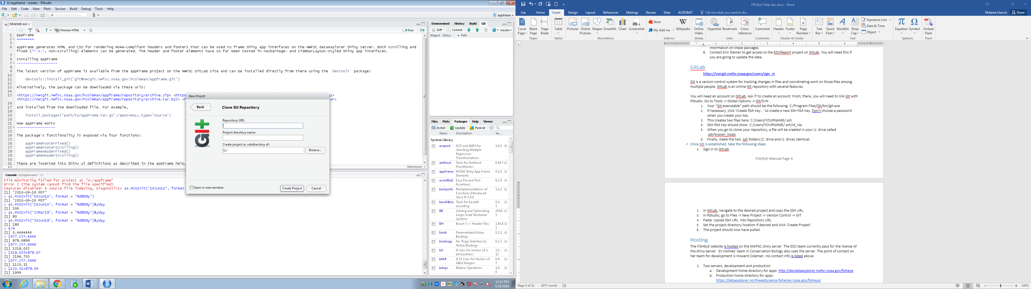

### Updating files on GitLab

Any time you change a file associated with FISHEyE, be it the data or shiny code, be sure to upload the updated file onto GitLab. Tracking changes to the data is required. This is perhaps one of the easier ways to track changes. The EDC team utilizes GitKraken to manage files on GitLab. Learning GitKraken is beneficial, especially if multiple people are working on a file or you want to explore an option without committing to the changes. However, this manual is meant as a bare bones manual, as a means to help anyone maintain FISHEyE with relative ease. For this reason, I focus on using RStudio to commit and upload changes.

In RStudio, there is a Git tab in the top right hand box

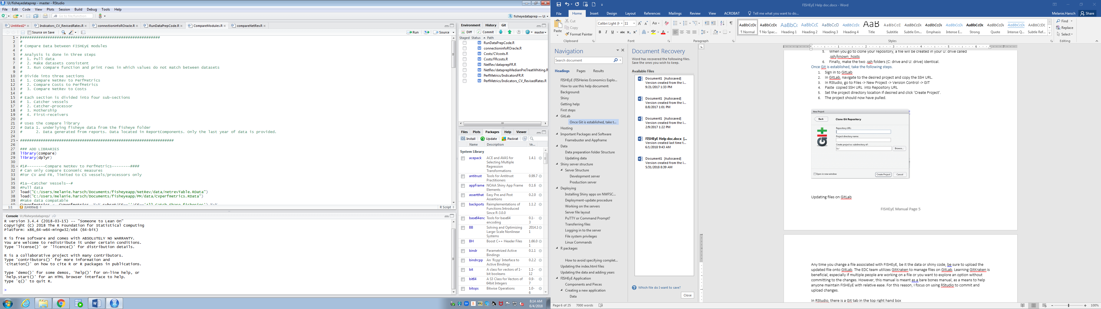

Click on Git. A list of files that have been changed should be listed. These files will be color coded based on how the file have changed – modified, moved, added, deleted. Blue is modified. Click on the open box next to a file and click ‘Diff’.

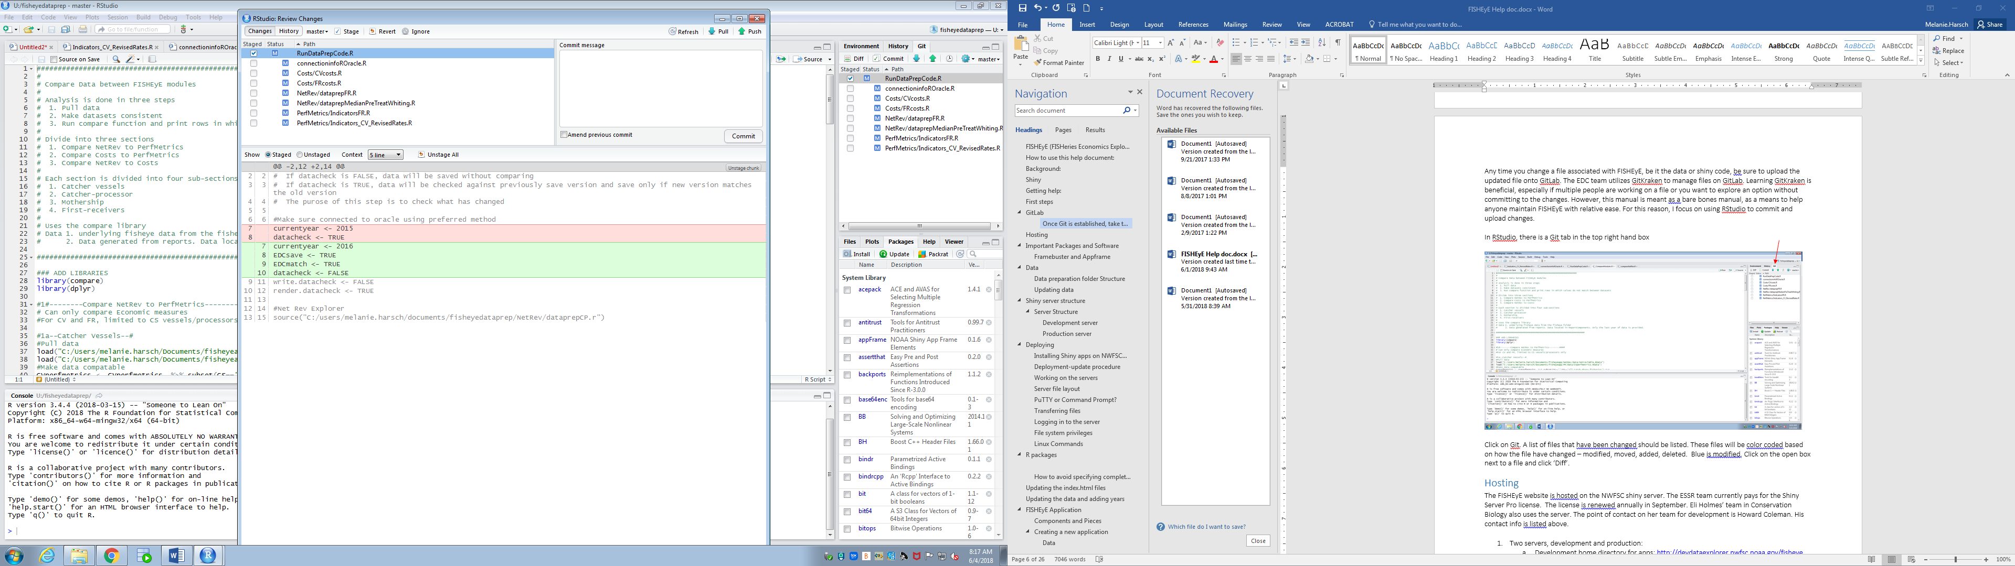

A window similar to the one above should appear. The red shaded text has been deleted. The green shaded text has been added. Add a brief but informative ‘Commit message’ that will aid in other’s understanding what you have done and will aid you in going back if need be. Here, I would write the commit message ‘Added code for automating datachecking in ‘RunDataPrepCode.R’. Press the Commit Button. The press the ‘Push’ arrow to push changes into GitLab. You can save a commit message for multiple files by selected all the empty check boxes. In this example, all changes are related to the ‘RunDataPrepCode.R’ file, so I saved the commit message for all files and pushed them all at once.

## Hosting

The FISHEyE website is hosted on the NWFSC shiny server. The ESSR team currently pays for the Shiny Server Pro license. This is the license for the software, not the server itself, and is renewed annually in September. At the time of writing this manual, Lisa Pfeiffer was handling this. Sarah Kurochkin (sarah.kurochkin@noaa.gov) is probably the best person to contact regarding the renewal process. Eli Holmes’ team in Conservation Biology also uses the server. The point of contact on her team for development is Howard Coleman. His contact info is listed above.

There are two servers, the development and the production servers:

1. Development home directory for apps: <http://devdataexplorer.nwfsc.noaa.gov/fisheye>
2. Production home directory for apps: <https://dataexplorer.northwestscience.fisheries.noaa.gov/fisheye/>

The development server is for testing and can only be viewed within the nwfsc network. For more information on why there are two servers go to the Shiny server structure section.

1. Point of contact for server maintenance: Marcus Nedelmann [Marcus.Nedelmann@noaa.gov](mailto:Marcus.Nedelmann@noaa.gov)
2. Point of contact for website maintenance: Howard Coleman [howardcoleman@gmail.com](mailto:howardcoleman@gmail.com)

## Important Packages and Software

All shiny programs should include two additional packages. These packages can be downloaded from GitLab. Contact Howard Coleman to get permission to access these R projects housed on GitLab.

1. [appFrame](https://nwcgit.nwfsc.noaa.gov/hcoleman/appframe): Header and footer template
2. [shiny_framebuster](https://nwcgit.nwfsc.noaa.gov/hcoleman/shiny_framebuster): A temporary security fix for shiny apps. RStudio is working on a patch to address cross-frame-scripting so you may not need this package in the future.

You will need additional software. Put in a helpdesk request to have IT install any software not on your computer. Software you will need:

1. PuTTY: <http://www.putty.org/> PuTTY is an SSH and telnet client. It is open source software. You will need it to transfer files from the local directory on your computer to the server. Details on how to use PuTTY are provided in Shiny server and Deploying. You need putty.exe and pscp.exe.
2. RStudio
3. Oracle SQL Developer (for working with the raw data in the fisheyedataprep R project folder.

## Framebuster and Appframe

The Framebuster and Appframe packages are necessary to run FISHEyE. Framebuster and appframe are already in the R library on the server. To run the FISHEyE modules locally (on your computer), the two packages must be installed locally or the call to these packages in ui.R should be commented out – but only locally. To load them, open the project in RStudio. Under ‘Build’ in the upper right-hand panel, click ‘build and reload’. You should not have to do anything else. You may need the devtools package to build and reload the appframe and framebuster packages. If you do, type ‘devtools::install_github("r-lib/devtools")’ into the R console. Follow the same procedure to build and load EDCReport.

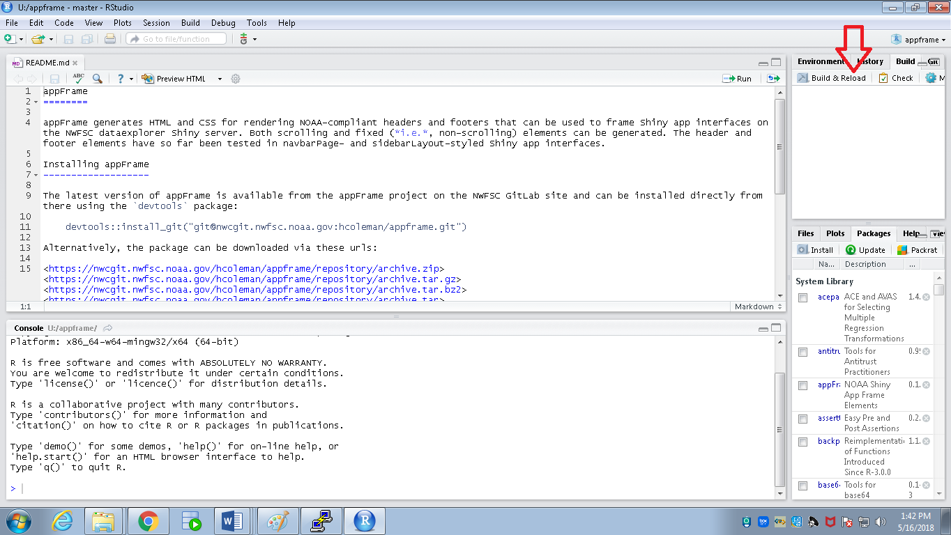

# Data

Due to security concerns, raw data cannot, at this time, be loaded onto the shiny server. Data are subsetted from a large table based on the selected parameter rather than analyses conducted on-the-fly. This means that all the analyses and data checking must be conducted locally and the finalized flat data table loaded onto the server. This flat file is the output for every possible permutation on FISHEyE. The code to generate the data is in the fisheyedataprep R project.

## Data preparation folder Structure

Blue boxes represent folders, orange boxed are just categories to aid in interpretation and green boxes represents R data files. For the Net Revenue application, there are two data tables for each sector. For CV, the analyses for the two data tables are split into two separate R files. For the other sectors, code to generate both data tables are in the same R file. When the R file is run, an intermediate flat file is outputted to S:/FRAM/ESSR/FISHEyE. This is so that the EDC team has a copy of the data in case they need to conduct any data checking or resolve questions.

## Updating data

To update data files on FISHEyE open:

RunDataPrepCode.R

CompareNetRev.R or CompareMS.R

Compare Modules.R

RunDataPrepCode.R calls the individual data files shown in green above. Specify the desired last year of data at the top of the R file. Data files can be updated using the individual data files in green above but this is not necessary. They should be opened if the code, outside of the last survey year, needs changing. Several checks are built into both RunDataPrepCode.R and the individual data files. Updated FISHEyE data will not be saved if the data do not pass the checks. These include:

EDCsave

EDCmatch

datacheck

write.datacheck

render.datacheck

EDCsave defines whether the intermediate flat file should be saved to S:/FRAM/ESSR/FISHEyE. Generally, only save the intermediate file if updating data on the server. The flat file is saved if EDCSave is TRUE.

EDCmatch defines whether the fisheye data must match the EDC data. If EDCmatch is TRUE then the generated data will be saved only if the generated data table matches the EDC data. The two files will be compared regardless of EDCmatch value. A comment will appear in RStudio stating whether the files match. In general, FISHEyE data should not be saved if it does not match EDC data.

Datacheck defines whether or not to compare newly outputted data against the previously saved data. It is primarily a check against changes to the code to generate the data. Unless the underlying data has changed, the two data files should match. This is check is not useful if the data needs updating (such as a new year of data). Datacheck should be used to evaluate impact of changing the data file code or when updating the data mid-year. Write and render data check will save and display the output of the comparison between the new and previously saved datasets. The new data will automatically be compared against EDC data and the outcome of the comparison will be displayed. Note, unless ‘datacheck’ is false, the data will not be updated if the new data file does not match the old data file.

Compare Modules.R

It is important to ensure that the data loaded onto FISHEyE matches the data in the EDC reports. FISHEyE data is compared against EDC report data at several points. First, the raw data is compared. This can be done with EDCMatch. FISHEyE data has already been updated, means and medians can be compared against EDC data using ‘CompareNetRev.R’ and ‘CompareMS.R’.

Once all data files are updated, the ‘Compare Modules.R’ file should be opened. This data file compares output that is available across modules for each sector, such as revenue, fixed costs, and variable costs.

### A note on Oracle

You will need an oracle account to update the data. Data for FISHEyE is pulled from the framdw database. The EDC team is, at the time this manual was written, using ROracle to interface with Oracle through R. You will need to install the DBI and ROracle packages in R. The best method, at the time this manual was written, was to download ROracle from <http://www.oracle.com/technetwork/database/database-technologies/r/roracle/downloads/index.html>. I downloaded the windows version of the most recent version. After download, install in R using the following code (although change the file path as appropriate).

install.packages('C:/Users/melanie.harsch/Downloads/ROracle_1.3-1.zip', repos = NULL)

In the fisheyedataprep project you will need a connectioninforROracle.R files. Below is the code that is in the file. Change the x’s to your username and password.

#install.packages('C:/Users/melanie.harsch/Downloads/ROracle_1.3-1.zip', repos = NULL)

library(DBI)

library(ROracle)

ora <- Oracle() ## or dbDriver("Oracle")

framdw <- dbConnect(ora,

username = "xxxxx",

password = "xxxxx",

dbname = "framdw")

The data files have two lines of code that source the information to connect to Oracle. Change the file path if necessary.

source("U:/fisheyedataprep/connectioninfoROracle.r")

preventingprintingtoconsole <- dbSendQuery(framdw, "alter session set current_schema=FRAM_ANALYSIS_CURRENT")

# FISHEyE App (fisheyeapp R project)

Each FISHEyE application has essentially the same pieces.

Description of the files and folders:

ui.R: User interface. This defines the appearance of the app and how users interact with the app. If you need a library for a front-end element, like headers/footers, it goes in ui.R

server.R: Server side. Applications or script run on the web server.

Client (your computer) makes a request from FISHEyE). Example: Plot net revenue for whiting vessels

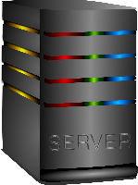 

The relevant script are processed on the server. In this example, subset the data and plot the data. Output is returned to the client.

global.R : define currentyear in this file and holds critical information for the bookmarking function.

external folder: Holds all the files used in server.R

serverHead.R: call to load the data

explorer folder

explorer.R: sources files that are held in explorerSourceFiles folder. These files define the widgets in the ui, subset the data, define plotting functions, etc. Also contains code for the information icons, renderPlot and renderTable functions, and code for interactive plots

explorerSourceFiles folder

ex.io.sidebar1.R: Defines widgets. Widgets are the drop down menus, select input, checkboxes, etc in the Control Panel

ex.reactives.R: All data processing/subsetting is done is this file

doPlot.R: function defining appearance of the plot rendered on the webpage

doPlotDownload.R: function defining appearance of the plot that will be downloaded. There are slight differences doPlot and doPlotDownload. These are done separately to optimize appearance.

about.R: Text that appears on the front page of the module

deftaulText.R: Text here is for the Blog, FAQ, Get Started Tab, Case Study, Email, Links to other FISHEyE applications.

defintions.R: Text for the definitions tab.

instructions.R: Text for the instructions tab

data folder: All the data is in this folder. The call to load the data is in external/serverHead.R

www folder: This folder contains images to be displayed, css files (which describe how HTML elements are to be displayed), and javascript. Additional files are in the www folder. These files are images that are embedded onto the FISHEyE application pages.

Keep these files and folder in www

bootstrap.css

bootstrap_nwfsc.css

fisheye.css

Definitions_files

Definitions.html

message-handler.js

header_noaa_l.png

header_noaa_r.png

# Shiny server

There are two servers, the development and production servers. The **development** **server** is visible within the NWFSC (including VPN) and is a great place to test the functionality of the application and seek feedback before making changes public. The **production server** is public and apps on this server are accessible from the Internet at large. To update files on the server you will need to access the server. This cannot be done in R. You will need to understand the server structure along with how to use a network file transfer application, such as PuTTY. This section of the manual provides an outline of the server structure: urls, folder and file structure, etc. The next section, Deploying and Updating on the server, provides detail on PuTTY, how to move around in the server, and how to update files on the server.

## URLs

The development server base URL is

<https://devdataexplorer.nwfsc.noaa.gov/fisheye/>

and the production server base URL is

[https://dataexplorer.northwestscience.fisheries.noaa.gov/fisheye](https://dataexplorer.northwestscience.fisheries.noaa.gov/fisheye/)

For reference, the Conservation Biology Division development URL is

<http://devdataexplorer.nwfsc.noaa.gov/nwc>.

Each Shiny app resides in a subdirectory under one of these paths. For example, the Net Revenue Explorer app on the production server is accessed via the URL

[https://dataexplorer.northwestscience.fisheries.noaa.gov/fisheye/NetRevExplorer](https://dataexplorer.northwestscience.fisheries.noaa.gov/fisheye/NetRevExplorer/)

## Server file layout

The Shiny Server files reside in the directories /srv/shiny-server/fisheye.

Every Shiny app has its own subdirectory of one of those directories: the files for the Net Revenue Explorer app are in the /srv/shiny-server/fisheye/NetRevExplorer directory.

The chart below outlines the folder structure for the development and production servers. Note that the server structure matches the structure of fisheyeapp R project. Also, note that the folder name for the Net Revenue Explorer application differs between the development and production servers. Blue boxes indicate folders. Orange boxes indicate files. Notice the www folder is like a ‘catch-all’. All the files that are used to modify the basic appearance of the app, such as add embedding figures or changes to the css code or adding javascript code, are here.

There are also static HTML pages serving as landing pages or "tables of contents". One of them, /srv/shiny-server/index.html, provides links to the fisheye and nwc subdirectories from the Shiny Server's homepage. As both the CB division application (nwc) and FISHEyE share this file, check with Howard Coleman and Eli Holmes before making changes. Within the fisheye directory, one more index.html file that provides links to the individual apps. This,  /srv/shiny-server/fisheye/index.html, is the landing page and will need updating when you install a new Shiny app or remove an existing one.

### Development server

### Production server

## Deploying and Updating and on the Server

This is a how to for installing and updating Shiny apps on the NWFSC Shiny development and production servers. It includes notes on using the development server for testing, how and where to copy Shiny app files, how to update index pages, and how to install and update necessary R packages. The next subsection provides a basic outline of the approach I take when updating FISHEyE. More details on each step are outlined in the subsequent subsections.

### Deployment-update procedure

It may be helpful to follow these steps when you move a new Shiny app or changes to an existing app from your own computer to the production Shiny Server.

1. Get the app working locally on your computer. On the server.R or ui.R file, click the Run App icon or type Shiny::runApp() in the console. Trouble shoot any problems here.
2. Copy the app directory (or files in that directory that have changed) from your machine to the **development server**. You will need PuTTY for this. (See PuTTY section below for suggestions about how to do that.)
3. If any new packages or updates to existing packages are needed, install those on the development server. (See R packages sectionfor how to do that.)
4. Note that the call to tags$head(tags$body(includeHTML("google-analytics.noaa.js"))), needs to be commented out on the development server. This is the first thing to check if the web app crashes. Make sure this line is not commented out on the production server or we won’t be able to collect any analytics on site usage.
5. If you are adding a new app, update the index.html file in the fisheye subdirectory on the server to provide a link to the app (see index.html section).
6. At this point, the app should be operational on the development server. This is a relatively safe place for debugging, because the development server is not visible outside of the NOAA network.
7. Test the app on the development server. Share the app with trusted colleagues to help with proof reading and finding code breaks. Make sure every plot and download possibility works and doesn’t look funny.
8. Once you're happy with the app's behavior on the development server (and you have all the appropriate go-aheads from project leaders and other concerned parties) **install the app on the production server** following the same steps:
9. Copy the app files to the production server.
10. Install or update R packages.
11. Update the appropriate index.html file if appropriate.

A note of caution when transferring between your desktop and the server. Windows file names are not case sensitive, linux is. This will leave you with a very difficult debug scenario on the shiny server (e.g., file ending in .r vs. .R)

## PuTTY or Command Prompt?

Don’t skip reading this section. The next section describe how to add files and make changes to files on the server. There are two ways of working on the server, one is to use a network file transfer application such as PuTTY, the other is to use PSCP or similar. PCSP is the PuTTY secure copy client and is a tool for transferring files securely using an SSH connection. It is a command line application which means it must be brought up in a console winder such as Command prompt. There are instances when one approach is more appropriate than the other.

Open command prompt to transfer files to or from the server. Open PuTTY to manage passwords, manage permission codes of files and folders on the server, and to directly modify the files on the server. Use PuTTY to modify or add content to the landing page (<https://dataexplorer.northwestscience.fisheries.noaa.gov/fisheye/>).

Below is a screen shot from an open session in PuTTY. In this screenshot, I am in the Net Revenue Explorer app on the development server. The line starting with ‘cd’ changes the directory. Typing ‘ls‘ brings up all the files and folders in the directory. You can see there are four folders (in blue), two R files and two JavaScript files (.js) (in white). Typing ‘cd data’ would open the data folder. Typing ‘ls’ would again display the files and folders within this folder.

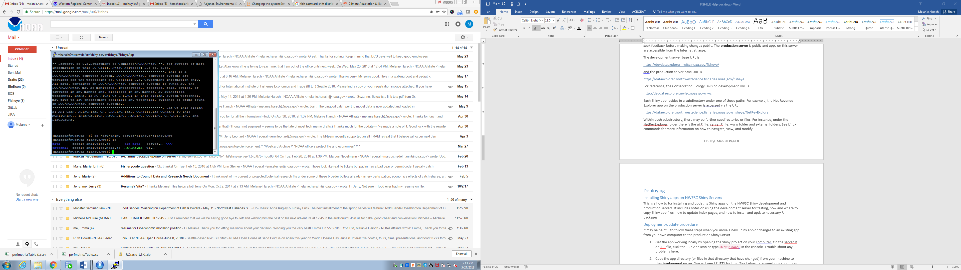

## Transferring files

You can transfer files by using a file-copy application from your local computer, such as PuTTY and a command line application like pscp brought in in Command prompt. You can also use the GUI tool of your choice but I used PuTTY, so this tutorial will focus on that.

Alternatively, you can archive the files you want to copy into a zip or tar file, copy the archive to the server, and extract the archived files into the appropriate locations on the server. This approach requires that you log on to the server (open PuTTY for this approach rather than call PuTTY through command prompt).

Below are the steps I took to transfer files

1. Open Command prompt (you can do this by clicking the windows icon and then typing ‘cmd’ into the search bar).
2. Set the path to the PuTTY files. You may need to change the ‘C:/Program Files (x86)’ portion of the text below, depending on your path to PuTTY.

set PATH=C:/Program Files (x86)/PuTTY;%PATH%

1. Begin transferring files
   1. Single file – this example copies the ui.R file in the Costs Explorer project to the development server.

pscp U: /fisheyeapp/Costs/ui.R mharsch@nwcrweb.nwfsc.noaa.gov:/srv/shiny-server/fisheye/Costs

* 1. Directory – this example copies the entire contents of the Costs project to the development server

pscp –r U:/ /fisheyeapp/Costs/ [mharsch@nwcrweb.nwfsc.noaa.gov:/srv/shiny-server/fisheye/Costs](mailto:mharsch@nwcrweb.nwfsc.noaa.gov:/srv/shiny-server/fisheye/Costs)

This is what the above command looks like in a session. The red arrow points to where I made an error. Simple errors (like leaving out a colon) are often the causes for error messages.

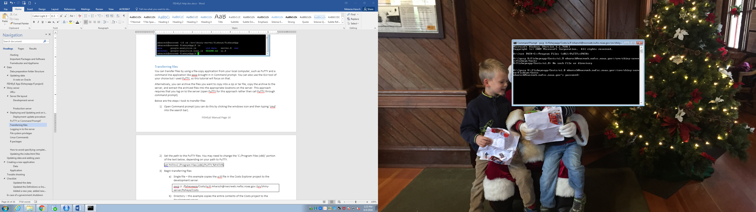

1. If it is the first time a file has been transferred to the server (not an update) or a folder was created, you will need to change file permissions. FISHEyE will not load on the server if inappropriate file permissions are defined. The appropriate command lines to change file permissions are provided in the Linux Commands section. You will need to launch your SSH client to change file permission (e.g. PuTTY, see next section).

## Logging in to the server

This describes how to log on to the development and production servers using a file transfer application, such as PuTTY. Reasons to do this,

1. Change file permissions
2. Edit or remove files
3. Change password
4. View Folder contents, file permissions, and data modified
5. Install and update R packages.

To use GUI tools for this purpose, you will need to follow the instructions for the tool you select. I used PuTTY, so I will provide details for PuTTY.

Launch an SSH client on your computer.

On OS X or *nix systems this can be done in a Terminal or other bash shell window by typing

% ssh <serveraddress>

From a Windows system, you can use a client such as Putty by clicking on the executable file.

The development server address is nwcrweb.nwfsc.noaa.gov and the production server address is nwcshiny.nwfsc.noaa.gov.

These servers host the files served by the Shiny servers, and their addresses take the place of <serveraddress> in the login command above. These addresses are only visible from the NOAA network, so to access either server you need to be on the NOAA network.

Option 1) Assuming you're using a command-line SSH client, log onto the development server by typing

% ssh username@nwcrweb.nwfsc.noaa.gov

replacing "username" with your account name and supplying your password at the prompt.

Your working directory will initially be your user directory on the server: /home/username. The Shiny app files and index.html files are located under the /srv/shiny-server/ directory as described above.

Assuming you use PuTTY. Open the PuTTY application. The following window should open.

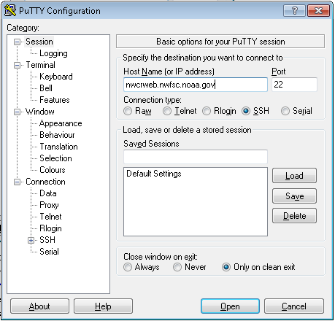

In the ‘Host Name’ section, type the directory you want and press ‘Open’ button. The above example is for the development server.

Production: nwcshiny.nwfsc.noaa.gov or Development: nwcrweb.nwfsc.noaa.gov

A prompt will appear asking for ‘login as’. Type your user name. Do not include @nwcrweb.nwfsc.noaa.gov. My login is below.

login as: mharsch

The prompt will then ask for your password.

You have now logged into the shiny server.

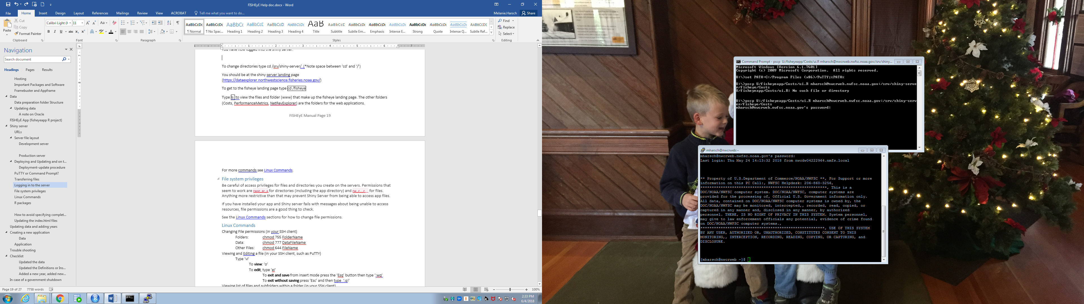

To change directories type cd /srv/shiny-server/ (*Note space between ‘cd’ and ‘/’)

You should be at the shiny server landing page (<https://dataexplorer.northwestscience.fisheries.noaa.gov/>)

To get to the fisheye landing page type cd /fisheye

Type ls to view the files and folder (www) that make up the fisheye landing page. The other folders (Costs, PerformanceMetrics, NetRevExplorer) are the folders for the web applications.

Below shows the use of ‘cd’ and ‘ls’ to change direction and view files. Changing file permissions is also shown.

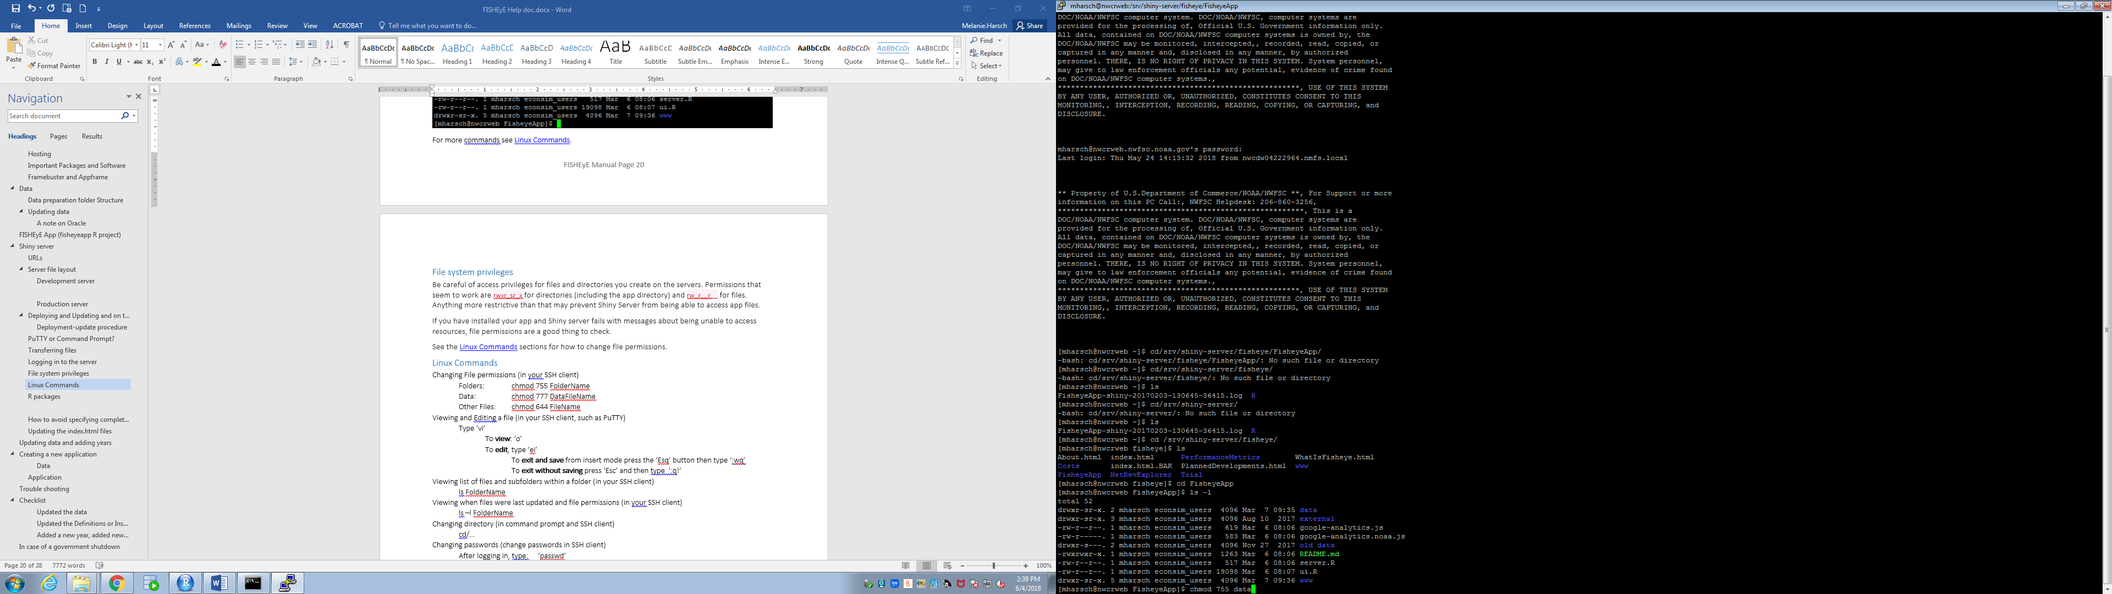

### **File system privileges**

Be careful of access privileges for files and directories you create on the servers. Permissions that seem to work are rwxr_sr_x for directories (including the app directory) and rw_r__r__ for files. Anything more restrictive than that may prevent Shiny Server from being able to access app files.

If you have installed your app and Shiny server fails with messages about being unable to access resources, file permissions are a good thing to check.

You change file permissions in your SSH client, such as PuTTY. The file permission codes depend upon the file.

Folders: chmod 755 FolderName

Data: chmod 777 DataFileName

Other Files: chmod 644 FileName

### Viewing and editing a file on the server

Again, you will need to do this in your SSH client, such as PuTTY. Navigate to the folder containing the file you want to change.

For instance: cd /srv/shiny-server/fisheye/Fisheyeapp

Then ‘vi ui.R’

Alternatively, simply type ‘vi /srv/shiny-server/fisheye/FisheyeApp/ui.R’

‘vi DataFileName’ will open the file. For instance in the screen shot below I type ‘vi ui.R’ while in the FisheyeApp folder. (screen shot on next page).

A series of further commands can be used here.

**view**: ‘o’

**edit**, type ‘ei’

After pressing ‘ei’, move around with arrows and directly change the text. To comment out text, add # to the beginning of the line.

When done, viewing or editing you will need to exit out of ‘vi’

**exit and save** from insert mode press the ‘Esq’ button then type ‘:wq’

**exit without saving** press ‘Esc’ and then type ‘:q!’

You need to press ‘esq’ followed by ‘:q!’ to exit if you typed ‘o’.

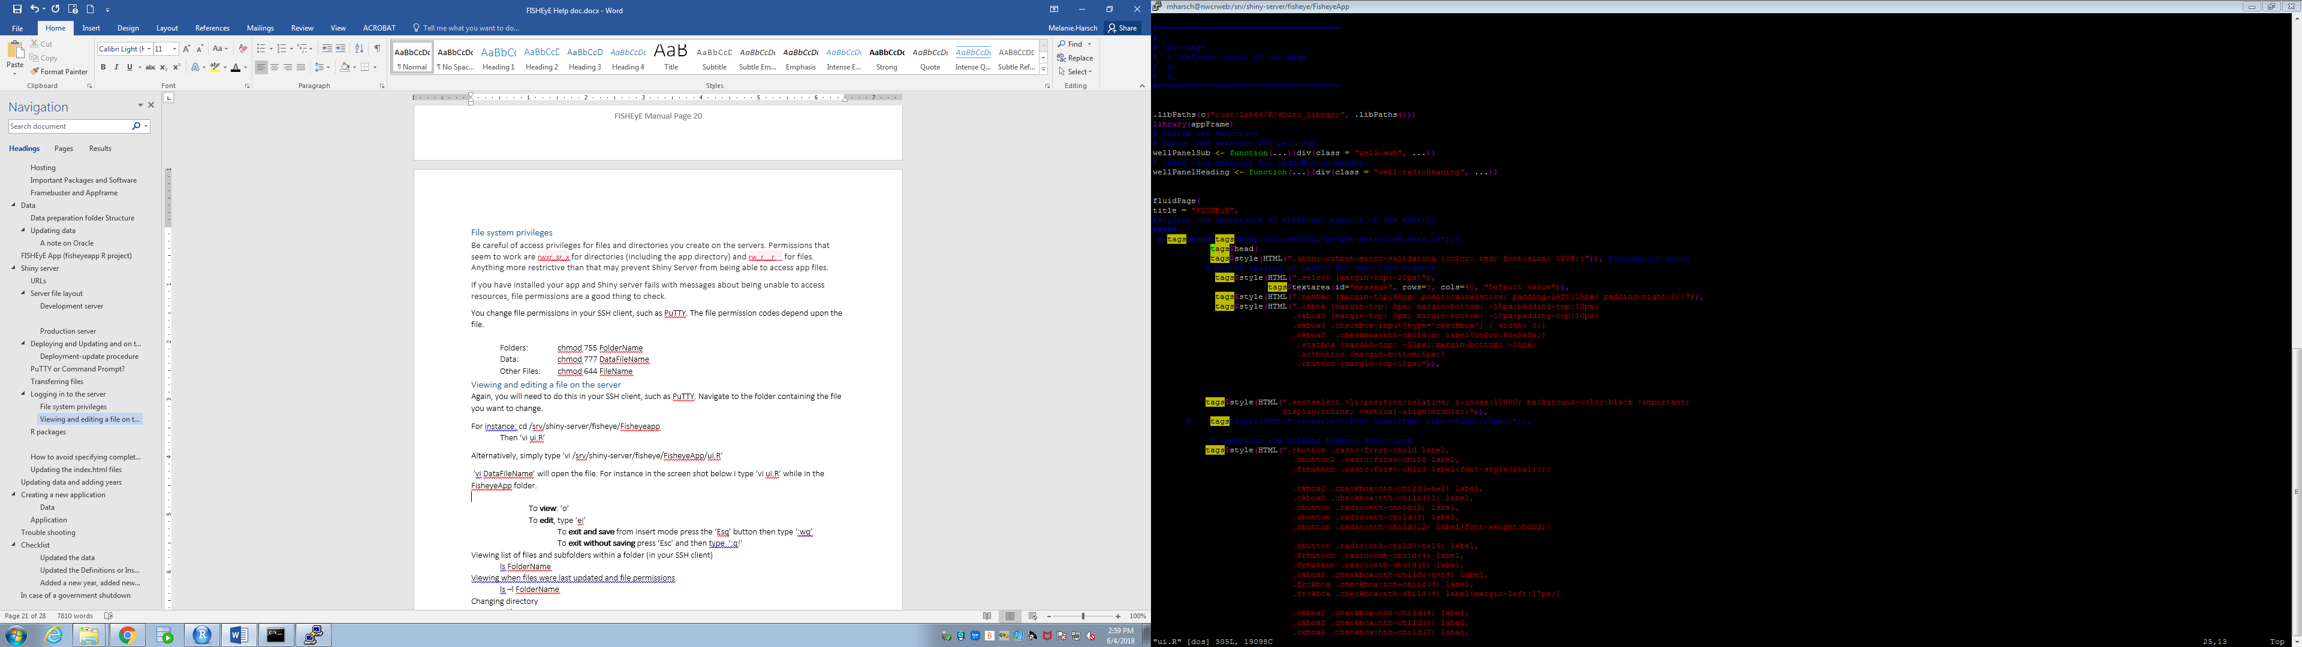To

### Other linux commands

Viewing list of files and subfolders within a folder (in your SSH client)

ls FolderName

Viewing when files were last updated and file permissions

ls –l FolderName

Changing directory

cd/…

Changing passwords on server

After logging in, type: ‘passwd’

### Transferring files codes (command prompt)

Loading a file

pscp LocalDirector username@PathToApp

Loading a folder recursively (command prompt)

pscp –r LocalDirector username@PathToApp

*Note that the files are written for the public server. This results in two critical points when updating files on the development server. 1) The links to other fisheye applications will be for the public server not the development server. 2) The updated web application WILL NOT WORK **UNLESS** youdelete this line of code from the ui.R file:

‘tags$head(tags$body(includeHTML("google-analytics.noaa.js"))),’

This line of code is at the top of the file and can be deleted after updating the files in command prompt by typing

vi path/to/ui.R

ei

Then place a ‘#’ before the line of code

‘esq’ “:wq”

To delete a file or folder (SSH client)

rm FileName

rm –r FolderName

An example of linux commands used in PuTTY

|  |  |
| --- | --- |
| **Code** | **Action** |
| cd /srv/shiny-server/fisheye/ | Takes me to the landing page |
| ls -l | View files and when last changed along with file permissions |
| vi index.html | View html code for landing page |
| ei | Edit and insert. Can no move around html code and make change |
| Esc wq | Save and exit (Esc q! will just exit) |
| cd PerformanceMetrics | Change to performance metrics folder |
| chmod 644 ui.R | Change file permissions on ui.R |
| cd /srv/shiny-server/fisheye/ | Back to landing page |

## R packages

Note updating R packages is done in your SSH client, such as PuTTY.

Even if you're using other tools to transfer files to the servers, you may still need the command shell to install and update packages in R so that they will be visible to Shiny Server.

Shiny Server and its R session run as a privileged user on the server. Access to the directories where R keeps its package files is limited so that the Shiny Server user can install packages there, but your login account cannot. When you install a package in R, its files will go by default into your personal package directory - something like R/x86_64-redhat-linux-gnu-library/3.x, relative your home directory.

Apps running on the Shiny Server will not be able to load packages from your directory, so you have to put them where they can be accessed. That location is the /usr/lib64/R/shiny_library/ directory. Your account has permission to write files here, and the Shiny Server process has permission to read them.

To install a package /usr/lib64/R/shiny_library/ from inside R, start R by first logging into the server and then typing

% R

To check which packages are installed, type

> library()

To install the package NewPackage from a repository, type

> install.packages("NewPackage",lib="/usr/lib64/R/shiny_library",...)

Here, > is the R prompt and ... represents whatever other arguments you might need to pass to install.packages().

Similarly, install NewPackage from a file on the server with something like

> install.packages("/path/to/NewPackage.tar.gz",lib="/usr/lib64/R/shiny_library",repos=NULL,...)

To remove a package,

> remove.packages("NewPackage",lib="/usr/lib64/R/shiny_library")

## **How to avoid specifying complete package paths in your app**

This set of text is mostly informational. The necessary code is already within the established shiny codes.

The library path described above, /usr/lib64/R/shiny_library, is probably not among the library trees R uses to find specified packages. This means that, if you include the line

library(NewPackage)

in your Shiny app code, the Shiny Server R process may not be able to find the package because it isn't looking in the right place.

One slightly dicey way around this is to specify the entire path in your library() call:

library(NewPackage,lib.loc="/usr/lib64/R/shiny_library")

This may not be the best way to go about loading the package. Aside from requiring more typing, it may force you to load manually any dependency packages NewPackage needs before you load NewPackage itself.

Why? Suppose installing NewPackage required you to install OldPackage as a dependency. You installed OldPackage in /usr/lib64/R/shiny_library as you should. When Shiny Server's R process tries to load NewPackage, the OldPackage dependency is noted and R attempts to load OldPackage first. OldPackage isn't in the standard package tree, however, so the load fails.

To work around this you could manually load OldPackage before you load NewPackage, again specifying lib.loc:

library(OldPackage,lib.loc="/usr/lib64/R/shiny_library")

library(NewPackage,lib.loc="/usr/lib64/R/shiny_library")

With a few more dependencies, this becomes tiresome pretty quickly. Another approach is to modify the package tree to begin with, with a call (two calls, actually) to .libPaths() at the top of ui.R / server.R:

.libPaths(c("/usr/lib64/R/shiny_library",.libPaths()))

The rightmost .libPaths() call returns the default package location list. The c(...) call prepends /usr/lib64/R/shiny_library to that list. The extended list is then passed to .libPaths() to set the new library tree for your Shiny app. Now R will search /usr/lib64/R/shiny_library first when it tries to load a package.

The result is that you can simply use

library(NewPackage)

and R will look in the right place for it. It will also search /usr/lib64/R/shiny_library for any dependencies. A package (like standard R packages or even Shiny) that isn't in /usr/lib64/R/shiny_library will be looked for in R's standard library trees.

To view which packages are in the library:

library(lib.loc='/usr/lib64/R/shiny_library')

## Updating the index.html files

There are three index files. They house the code for the landing pages for fisheye (https://dataexplorer.northwestscience.fisheries.noaa.gov/fisheye/), nwc (https://dataexplorer.northwestscience.fisheries.noaa.gov/nwc/), and dataexplorer (https://dataexplorer.northwestscience.fisheries.noaa.gov/). These pages are external to the interactive web applications and will rarely need updating.

The index.html static HTML files depend on CSS and image files stored in the www subdirectories of the /srv/shiny-server, /srv/shiny-server/fisheye, and /srv/shiny-server/nwc directories that contain the index.html files. It's probably best to update these files by copying them to your local computer, editing your local copy, then copying your changed file back to the server. When you copy an index file to your local computer, it is a good idea to copy the appropriate www subdirectory as well in order for images and styles to be properly applied.

Typical updates will involve adding or deleting links to apps. Duplicating existing app entries to create new ones, then changing the app name and link in the new entry is a quick way to add a new app. Removing an app entry by commenting it out may not be a good idea, since the commented HTML can be seen by viewing the page source. Delete the entry instead.

An effort has been made to maintain a uniform style among the index files. If you need to make a change to the images or CSS files in the www subdirectory, it would be a good idea to let other developers working on the Shiny servers know about those changes.

Once you've updated an index.html file, it needs to be copied back to the server. If the file in question belongs in the fisheye or nwc directories, you can copy it directly to the server. Changing the /srv/shiny-server/index.html file requires system administrator privileges, so in the unlikely event you find yourself modifying that file, you'll need to give your updated file to the system administrator who can then copy it into place.

# Updating data and adding years

The data in FISHEyE will need updating as data are added and improvements and changes are made to the data and EDCReport. This section outlines the steps taken to generate, check and update the data.

1) Open RunDataPrepCode.R in the fisheyedataprep folder

2) Make and relevant changes and select data checking options before running

a) Make sure you are connected to oracle

b) Change ‘currentyear’ to the desired year

c) Review ‘datacheck’ option

i) datacheck

If FALSE, the updated data file will be saved without checking the updated data file against the previously saved version

If TRUE, data will not necessarily be saved. A set of code will be run that compares data resulting from the most recent generation of the data against the most recently saved version. If there are no differences, the data file will be saved. If there are differences, as will be the case when a new year of data is added, the new data file will be compared against the old data file and the number of rows that do not match between the data files will be reported.

iii) write.datacheck

If TRUE, then the data rows that do not match will be written to the saved working directory as diff.csv. This is useful to evaluating why the two data files are not matching. This function is from the daff library.

iv) render.datacheck

If TRUE, then the data rows that do not match will be displayed in the viewer. The highlighted column is where the mismatch occurs. This is useful for quickly visualizing where the differences exist. As only a subset of the data may be displayed, it may be useful to write the dataframe as a csv file and explore in externally. This function is from the daff library.

3) Click ‘Run’ on the desired file. Some files have built-in messages. For instance, the CV net revenue files (dataprepMedianPreTreatWhiting) automatically checks the outputted data against the data outputted in EDCReport. This may not match if the EDCReport data has not been updated. Also, semi-processed data (just after apply defl function but before generating means, medians, etc) are saved to S:/FISHEyE/.

4) If warning messages appear related to the datacheck functions, take a moment to figure out why. Rerun and save file when ready. The code will tell you the number of rows in which the value does not match between the previously save data and recently generated version. I used the daff library to check line-by-line all columns of the two datasets. Render.datacheck is useful for viewing difference but the entire dataframe may not be displayed. Use write.datacheck to view the entire mismatching dataframe externally.

Once any possible issues are resolved and data are saved, perform the following tasks.

* + 1. Data should automatically be saved into the appropriate FISHEyE app folders.
    2. If you added an additional year, further steps are required.

In the server.R file in each app, change currentyear. This should automatically change year in all relevant places (such as y label and years choices in the well panel.

Also update currentyear in the defintions.R file

* + 1. Open the defaultText file and update the blog to indicate that data have been updated or that a new year of data has been added. I list the date when data have been updated but not necessarily what was changed. This helps users know if their data is the most up-to-date and helps to identify why there may be differences in outcomes.
    2. Open the fisheye project (such as Costs Explorer) and run the app. Play around with the app and check that nothing is broken, that the updated data displays properly, etc. Try downloading data and plots. Check at least one variable from each sector and grouping variable (fishery, homeport, state, etc)
    3. If you’re happy, load the updated data and/or files on the development server. Again, check that the app is functioning properly. If all goes well, you can load onto the production server.

**Updating Data Checklist**

|  |  |
| --- | --- |
| Changed currentyear global.R (if applicable) |  |
| Checked functionality locally |  |
| Checked functionality on development server |  |
| Checked functionality on production server |  |

# Creating a new application

When building a new FISHEyE application, it is advisable to start with the application that is most similar to the one you want to build. The current applications have different attributes that may or may not be desired. Keep in mind that it is easier to remove complexity than to add complexity. The list above outlines the bare minimum of files that must be included.

### Data

Create a new subfolder in the fisheyedataprep folder. You will most likely want four files, one for each sector. Try to keep column headings of the final dataframe consistent with what has been used in other apps. This will make developing the shiny app easier. Update ‘RunDataPrepCode.R’ to include your new app and files.

## Application

Start by creating a new project and link to Git. Under file, click New Project ->New Directory->Shiny Web Application. Create a Directory Name and create the project as a subdirectory of fisheyeapp folder. ‘Create a git repository’101480

should be clicked. The new project will consist of a ui.R file and server.R file. Replace these and copy over the files from an existing fisheyeapp project. You will need all the files except some files in the www and data folders. New data files will need to be generated. In the www folder, keep

Definitions_files (file folder) and Defintions.htm

All css files (bootstrap.css, bootstrap_nwfsc.nooa, fisheye.css)

All javascript files (ending in .js; message-handler.js)

Some png files

WhitingFIgure.png

header_noaa_l.png

header_noaa_r.png

# Trouble shooting

* + 1. I created a new app that runs locally but I am just getting a greyed screen or a portion of my app isn’t showing up, like a new figure, isn’t showing up on the development or production server.

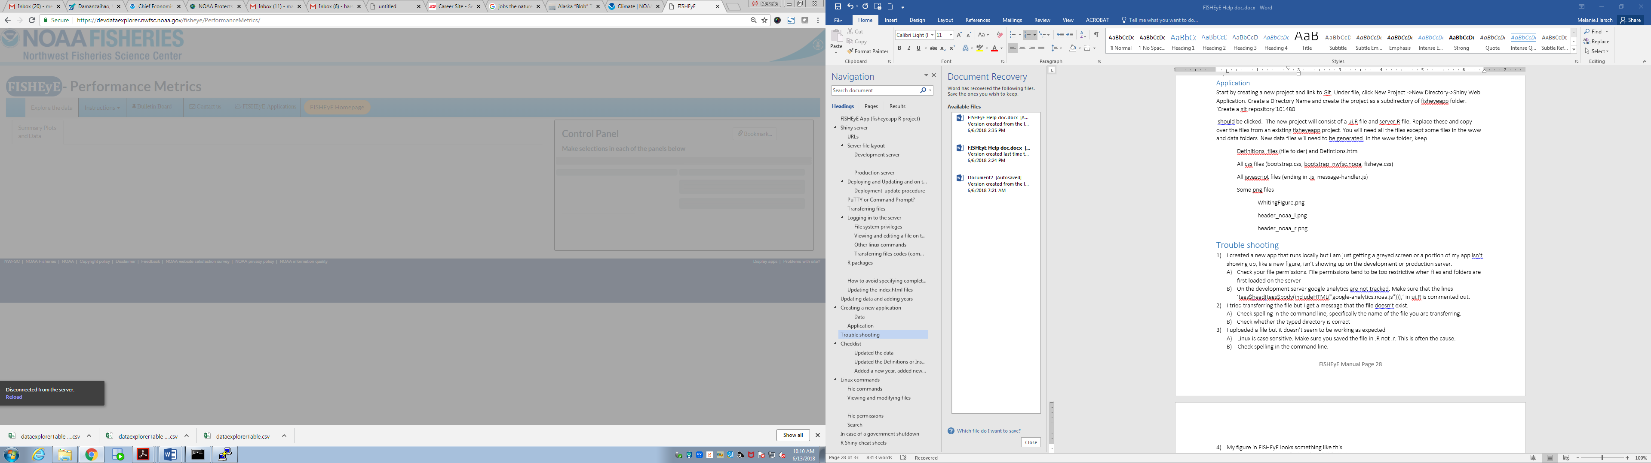

* + - 1. Check your file permissions. File permissions tend to be too restrictive when files and folders are first loaded on the server
      2. On the development server google analytics are not tracked. Make sure that the lines ‘tags$head(tags$body(includeHTML("google-analytics.noaa.js"))),’ in ui.R is commented out.
      3. If both solutions above are not the issue, right click on the app and then click ‘Inspect’. A window will open on the right hand of the screen. If you go into ‘Console’, you can see the errors, which may help you figure out why the app crashed.

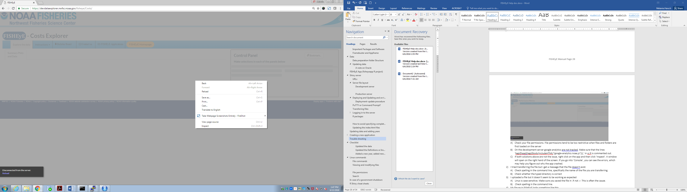

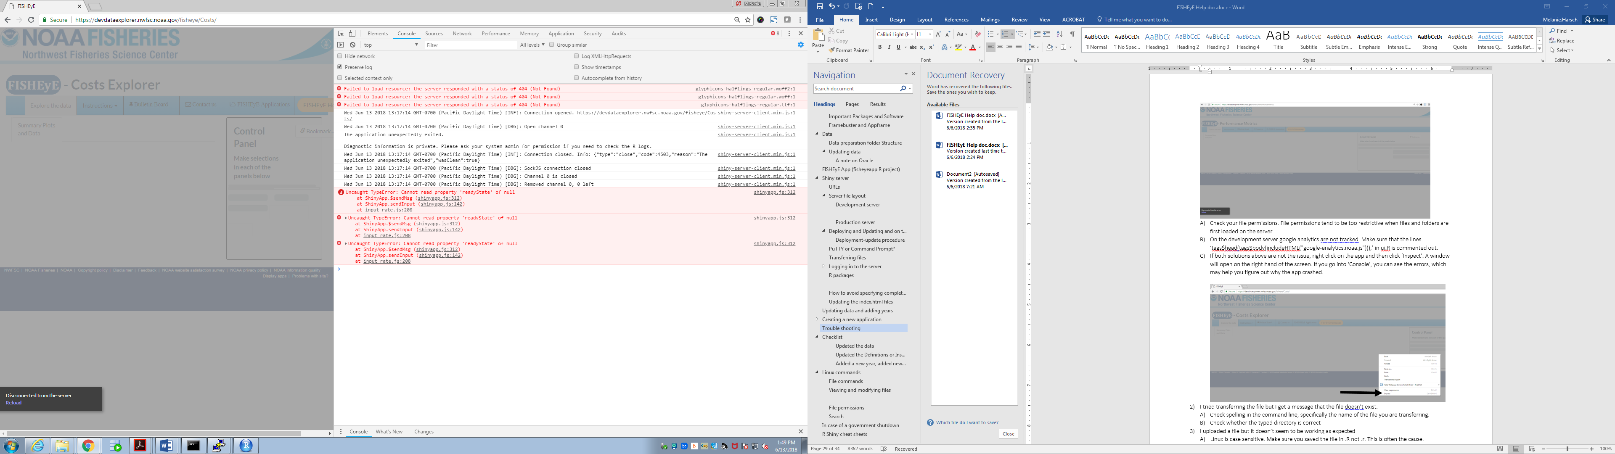

Error messages are in red. These messages may help in figuring the issue.

* + 1. I tried transferring the file but I get a message that the file doesn’t exist.
       1. Check spelling in the command line, specifically the name of the file you are transferring.
       2. Check whether the typed directory is correct
    2. I uploaded a file but it doesn’t seem to be working as expected

A) Linux is case sensitive. Make sure you saved the file in .R not .r. This is often the cause.

B) Check spelling in the command line.

* + 1. My figure in FISHEyE looks something like this

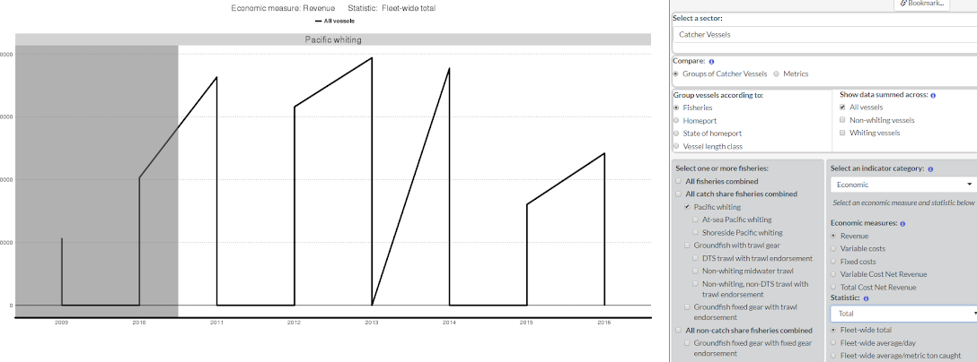

If your plot looks like the image above, it means that there are two data points or each year for the selected variable. You either have an issues with how the data is being subsetted in either the

* + - 1. Data (fisheyedataprep) or
      2. Subsetting in FISHEyE (ex.reactives page)

Unless ex.reactives was changed, check the code for generating the data first.

* + 1. FISHEyE isn’t loading but it did yesterday
       1. Questions to ask
          1. First, is the issue affecting just FISHEyE or is it also affecting the CB apps?
          2. Second, is the issue affecting both the production and development servers?
       2. If yes to both questions above, contact Marcus Nedelmann and Howard Coleman. Most likely it is an issue with some change that occurred on the shiny server and they can resolve the issue.
       3. If the issue is only present on FISHEyE, then it is something you need to deal with. See next Trouble Shooting example.
    2. FISHEyE loads but some aspects of FISHEyE will no work, such as plotting or the bookmarking button does not respond.
       1. Most likely the issue is due to updates in the installed packages. For plotting issues, check ggplot. For bookmarking issues, check for updated on the bookmarking function in the shiny app. Recent updates to shinyApp have required more specificity in the code for the bookmarking function. For instance, it once was default that the

# Checklist

A simple set of reminders to make sure all relevant files are updated when changes are made

### Updated the data

Record the date in the blog response

### Updated the Definitions or Instructions

Also update the Definitions.htm files in the www folder

### Added a new year, added new functionality, revised how a value is calculated, etc.

Consider creating a blog post (in the DefaultText.R file) if the change is a major update such as adding a removing a fisheries category.

# Linux commands

## File commands

|  |  |
| --- | --- |
| ls | directory listing |
| cd *dir* | change directory to *dir* |
| cd | change to home |
| mkdir | create a directory *dir* |
| rm *file* | delete *file* |
| rm –r *dir* | delete directory *dir* |
| cp file1 file2 | copy file1 to file2 |
| cp –r dir1 dir2 | copy dir1 to dir2 |
| pwd | show present working directory |

## Viewing and modifying files

|  |  |
| --- | --- |
| cat *file* | view the contents of *file* |
| head *file* | display the first 10 lines of *file* |
| tail *file* | display the last 10 lines of *file* |
| vi *file* | view file |
|  |  |

## File permissions

|  |  |
| --- | --- |
| chmod *octal file* | change the permissions of *file* to *octal* for User, Group, World by adding: |
| 4 | read (r) |
| 2 | write (w) |
| 1 | execute (x) |
| chmod 777 | read, write, execute for all |
| chmod 775 | rwx for owner and group, rx for world |
| chmod 755 | rwx for owner, rx for group and world |
| chmod 664 | rw for owner and group , x for world |
| chmod 644 | rw for owner, x for group and world |

## Search

|  |  |
| --- | --- |
| grep *pattern file* | search for *pattern* in *file* |
| grep –r *pattern dir* | search recursively for *pattern* in *directory* |
| locate *name* | find files and directories for *name* |

# In case of a government shutdown

In the case of a government shutdown, FISHEyE can remain accessible but a banner has to be enabled. The approved banner as of January 2018 is loaded and commented out. This will need to be made active during the shutdown.

Commented out sections are opened and closed with <!- - … - -!>

The text will be toward the top of the document, before the page title.

Only the production server (dataexplorer) will be affected.

To make changes, open PuTTY. Login to nwcshiny.nwfsc.noaa.gov

Type cd /srv/shiny-server/fisheye

Type: vi/index.html Press ‘ei’

Uncomment out the appropriate section. Click esq and type ‘:wq’

Make sure to re-comment out the section when the government reopens!

# R Shiny cheat sheets

Download at <https://shiny.rstudio.com/images/shiny-cheatsheet.pdf>

